ANNUAL REPORT & ACCOUNTS
AT 31 MARCH 2018

“Can You Hear Me Calling” by Centrepieces Artist Mark Harrison

CENTREPIECES ANNUAL REPORT & ACCOUNTS

1st April 2017 to 31st March 2018

Chairman’s Report:

It is with great admiration and respect for Geoff Norris our Volunteer Coordinator, the Patron, Trustees, Volunteers and Members of Centrepieces that I have witnessed the sustained growth of our organisation both in its activities and in the number of members who have joined us from the local community in Bexley and its neighbouring areas.
The organisation is like a ‘living entity’ reaching out to the people in need in our community and providing a tranquil safe haven for those who want to try something new in art and to practise and develop their artistic talents.
There is always a warm welcome at Centrepieces for new members and an impressive level of encouragement and support from existing members and volunteers.
I am truly proud to be associated with this wonderful organisation and to know all the great people in its development and operation.
It is with regret that due to personal circumstances that I have moved away from the South East of the country to the East Midlands and for this reason need to step down as Chairman of the Trustee Board.
I would still like to be involved as a Trustee and to attend significant events in the year to provide support to Centrepieces and its members in any way that I am able to help.
I am certain that the organisation will continue to flourish under the stewardship of Geoff and the Trustee Board and to gain further financial stability and sustainability.
I want to thank and congratulate everyone associated with Centrepieces for their efforts in making this a very special and greatly needed charitable organisation in Bexley; please give yourselves a deserved round of applause!
Andrew Grieve

Coordinator’s Report:

Over the last year we have seen another period of healthy growth by Centrepieces in its next phase of development as a mental health arts project.

Our artists, volunteers and Trustees have embraced the opportunity which was given to us by Bexley Council, who agreed to fund Centrepieces to create ‘Twelve’ temporary artwork installations in the grounds of Hall Place from October 2017 – April 2018. This has been a fantastic stimulus for the organisation which has brought everyone together, working both individually and as teams to design and submit proposals, and create the public artwork. It helped us to do exactly what we always aspire to achieve, involving the public in many of the projects, raising awareness and debate on mental health issues and producing a range of very interesting and varied sculptures and installations.
The team of volunteers supporting Centrepieces artists and project leaders to carry out projects like the ‘Twelve’ has been very solid this year, and have proved that our model can work very well, with volunteers who have frequently offered a tremendous amount of energy and creativity also benefiting themselves with many then moving on to work, or other areas of progression in their lives. We have consequently been recruiting new people who have also been able to offer their skills and experiences in different ways and from different perspectives. This is the nature of Centrepieces and helps towards keeping the project fresh and alive, with a core support of volunteers who are longer term. I would particularly like to thank Diana Donkor our arts administrator and Fiona Johansen who have now moved on, and Stuart Smith for his help with fundraising and film documentation. Also Karen Larkin who has been doing a great job as the new assistant coordinator and Christie Cassisa for her continuing work to inspire other artists through sculpture.
The programme of art workshops under the guidance of Karen has expanded this year with input from new tutors, all of which have been highly successful and include a wide range of activities and media including mosaics, decoupage, acrylic pour, mixed media and a creative writing class. There have also been workshops to support the ‘Twelve’ projects including the creation of Totems and Mushroom sculptures.
It is tremendous to be able to work in an organisation which has such an open feel of excitement and innovation, never quite knowing what to expect next.
Another highlight of last year was Centrepieces Annual Art Exhibition which took place in Dec 2017 in the Stables Gallery at Hall Place, a fantastic show rated by many (as usual) as the ‘best ever’!
Fundraising has been going particularly well, both through the efforts of our own volunteers, personal donations, membership, commissions on artwork sold and awards from other bodies, and also from unexpected sources such as the Dunton Green Dance Group, who held an entirely unsolicited event which raised £700 for Centrepieces, which they then donated as a new year present.
We have just completed the first year of a new 5 year lease with Bexley Council to occupy the Lodge at Hall Place. This has definitely gone very well, with a sense that we are finally in a more secure place both financially and organisationally, with a firm base to operate from. Long may it continue.
Lastly I would like to thank all our Trustees for their consistent hands on help and attendance at regular meetings to keep Centrepieces operating at the level we have been able, and I wish Andrew Grieve, our retiring chair, the very best for the future as he has done a lot for the organisation over many years, since its inception in 1999 through to acquiring the Lodge and becoming a Charity in 2015.

Geoff Norris

Legal and Administrative Information:

Registered Office Address:
The Lodge
Hall Place
Bourne Road
Bexley
Kent
DA5 1PQ

CIO Number: 1160300

Trustees of Centrepieces:

Andrew Grieve
Mike Ellsmore
Guy Tarrant
Britta Von Zweigbergk
Jenny Watson
Olwyn Sinclair
Rosie Eaglen

The Trustees named have served during the period of the accounts. Appointment of Trustees is governed by the CIO Memorandum and Articles of Association and the Trustee Board is authorised to appoint new trustees to fill vacancies arising through resignation, or the death of an existing trustee.

Structure, Governance and Management:

Centrepieces is a Charitable Incorporated Organisation (CIO) registered with the Charities Commission on the 3rd February 2015. The CIO has a volunteer Coordinator and a number of members who take on allocated voluntary responsibilities on a day to day basis. A Board of Trustees is responsible for the strategic direction and funding of the organisation, recruitment of new trustees as and when necessary, activities which are supported by 3 committees who meet periodically to discuss their specialist areas including Arts, Finance and Funding of the CIO, and then report to the full Board of Centrepieces.

Objectives of organisation:

To promote the recovery of adults in the London Borough of Bexley and surrounding areas who experience or have experienced, mental health problems by providing resources and support to enable them to participate in arts and related mental health enhancing activities, and to develop artistically and to achieve better social inclusion through art related activities.

- To promote mental health recovery through art
- To provide an outlet for artists with mental health issues to exhibit and sell their art-work
- To achieve long term financial sustainability
- To achieve long term security of tenure with regard to our premises
- To provide a safe and stimulating environment for our members
- To apply for available and appropriate funding
- To achieve a funding and income level allowing for the employment of paid staff

Centrepieces CIO – Financial Report

It gives us pleasure to present our third financial report, covering the year to the 31st March 2018.

Our third year has seen us further consolidate our financial position. Overall it was a highly successful year with our cash reserves increasing from £18,213 to £20,964.

The accounts presented are divided into unrestricted and restricted funds. Unrestricted funds can be used entirely at the trustees’ discretion. Restricted funds must be used for a specific purpose as prescribed by the donor. During this reporting period Centrepieces received donations on a restricted basis of £3,846 for the Art in Hall Place project which was funded by Bexley Council. Whilst the balance on the restricted funds is lower than last year at £121, a further donation of £3,552 is due from the Council.

Turning to our unrestricted funds, gross receipts totalled £20,454 whilst payments totalled £14,149. This resulted in a surplus for the year of £6,305.

At the end of the reporting period our unrestricted reserves totalled £20,843 up from £14,538 the previous year and are at an adequate level to ensure the continued operation of the organisation.

During the year we took on full leaseholder’s responsibility for the Lodge under a 5 year lease from Bexley Council. As a result we have significantly increased our running costs particularly in respect of rent, rates and utilities. At our financial year end £1,099 was outstanding in utility bills and as we account on a cash basis are not shown in the accounts.

In addition we have incurred additional maintenance costs particularly as a number of building inspections were required under the lease.

I am grateful to Jean Lyons and Annie Greywoode for their hard work and commitment in keeping Centrepieces finances in a well ordered and controlled state.

Michael Ellsmore, CPFA
Trustee

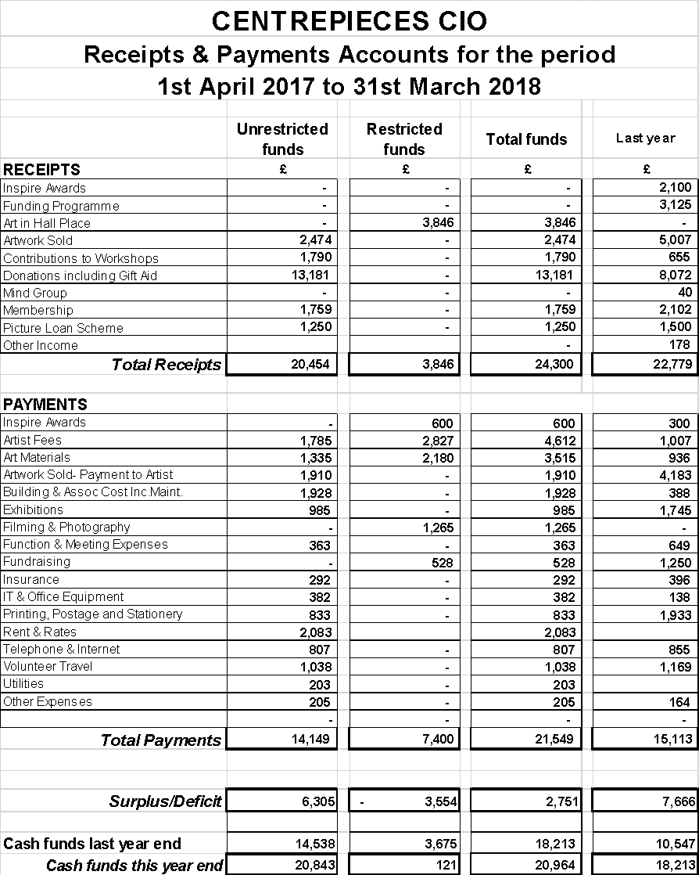

Financial statements report and review:

- In my opinion the accounts above give a true and fair view of the CIO affairs at the end of this financial year.

- Have been prepared in accordance with the requirements of the Charities Commission for Charitable incorporated Organisations (CIO).

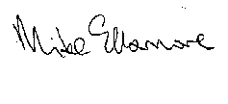
Mike Ellsmore CPFA
Trustee

Reserves Policy:

The Trustees have considered the level of reserves they wish to retain appropriate to the needs of the CIO. This is based on the size of the CIO and level of commitments held currently. The Trustees aim to ensure the CIO will be able to continue to fulfil its objectives even if there is a temporary shortfall of income.

Risk Review:

The Trustees conduct periodic reviews of the major risks to which the CIO is exposed and systems and procedures to manage those risks identified are implemented so as to minimise any potential impact on the CIO should any of those risks materialise.

Plans for the Future:

The CIO plans to continue its activities in the forthcoming year and beyond subject to satisfactory funding and income levels

We gratefully acknowledge and thank the support of:

- Oxleas NHS Foundation Trust

- The London Borough of Bexley

- Hall Place House and Gardens

