

ANNUAL REPORT & ACCOUNTS

AT 31 MARCH 2019

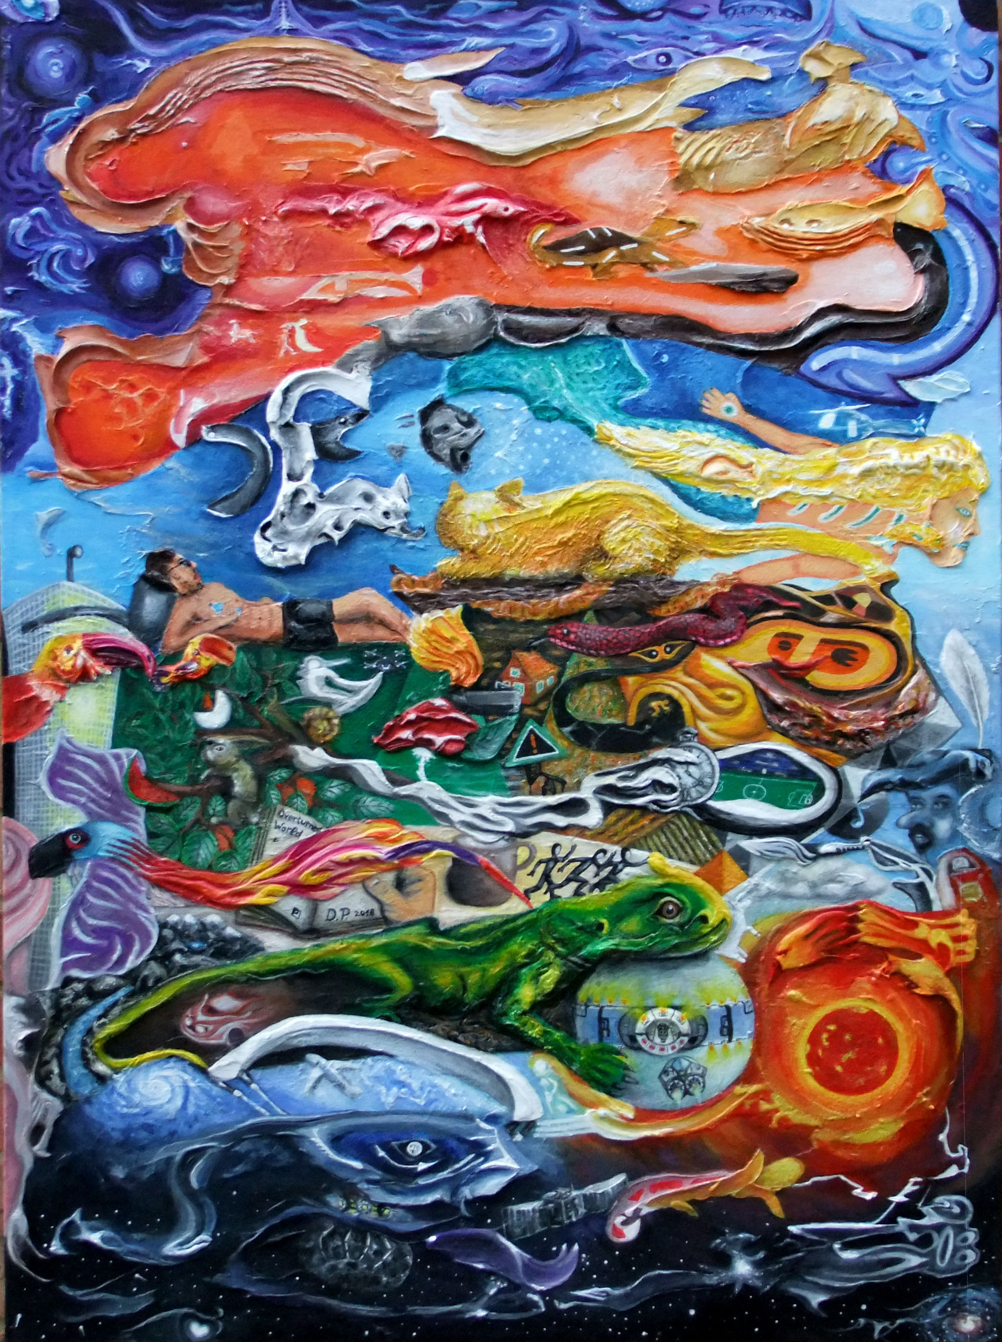

**“Overturned World” by Centrepieces Artist Danils Porubins**

**CENTREPIECES ANNUAL REPORT & ACCOUNTS**

1st April 2018 to 31st March 2019

**Chairman’s Report**:

This is my first Chair’s report having taken over from Andrew Grieve a year ago and I would like to start by thanking all the volunteers, donors and fellow trustees for their support over the past year. Without the help of so many there would be no Centrepieces.

The year has been one of great achievement for Centrepieces. I have seen the project go from strength to strength. Our range of activities, the quality of our artwork and most importantly the care we offer never ceases to amaze me.

What has particularly impressed me has been our increasing confidence in the way we do things whether it is putting on an exhibition, designing and constructing public art in Hall Place or publishing a book.

The world has become a more stressful and complex place where the digital age drives change all too quickly. Our job at Centrepieces is to provide a place where people can meet and alleviate some of the pressure of modern life through art

As Dorothea Tanning said, “Art has always been the raft onto which we climb to save our sanity. I don’t see a different purpose for it now”

Mike Ellsmore

Chair of Trustees

**Coordinator’s Report:**

Amazingly 2019 is officially the 20th anniversary of Centrepieces Mental Health Arts Project, and as one of the founder members I feel proud to have shared the journey from its very beginnings. One of our current Trustees, Britta von Zweigbergk has recently published a book entitled ‘Centrepieces, A Story of the Mental Health and Arts in Bexley’ which documents in a fascinating way the origins of the project alongside developments in art therapy from when Britta was the Head of Art Therapy at the old Bexley Hospital from the 1970’s onwards.

The way the project is run and its values in finding ways to help people recover from mental ill health through art have not really changed that much at all over the years. What has changed is the scale and ambition of the project, especially since moving to Hall Place in 2014 and becoming a Charity the following year. What we have now is around 130 registered members able to participate in a full programme of tutored art workshops, exhibitions, public art commissions and special events at schools and in the local community. All of this is supported by a dedicated team of about 30 volunteers, Trustees and Art Tutors.

Over the last year we have held our largest Art Auction ever, selling nearly £3K of artists work, and similarly our biggest exhibition in the Stables Gallery at Hall Place where we sold about £2.5K of work. Over 200 pieces of work were on display at each of these events, produced by about 50 Centrepieces artists.

Centrepieces has been busy creating opportunities further afield as well, having just held a ‘Body Image’ exhibition in Sandwich, Kent along the theme of Mental Health Awareness Week, and this summer we will be supporting solo exhibitions by 3 of our artists at the Creek Creative Gallery in Faversham. One of our artists, Mark Harrison has also negotiated for Centrepieces to display artwork in Bexleyheath Railway Station where he works on a rotational basis.

A good example of recent Centrepieces public artwork is the mosaic sculpture now installed in the gardens at Hall Place entitled ‘Broken Yet Still Beautiful’, which was funded through Sidcup Rotary Club.

As well as our regular exhibitions and picture loan schemes Centrepieces has just signed the lease to temporarily occupy the old Argos shop space in Bexleyheath, an exciting venture which we hope will open up even more possibilities for studio space for our artists, workshops, exhibitions and interaction with the public.

My personal thanks go to Karen Larkin, Centrepieces assistant Coordinator, who has been very busy organising the workshop programme and many other aspects of Centrepieces activities this year, and to all volunteers and tutors who have been helping out, some for many years now, and to new faces such as Lucy Thomas, Sue Turner, Aisling O’Daly, Joshna Mistry and Merissa Hylton.

And lastly a big thanks to Mike Ellsmore for taking on the mantle of Chair since Andrew Grieve left last year, and to the other Trustees who give such massive support through their regular contributions and meetings.

Geoff Norris

**Legal and Administrative Information:**

**Registered Office Address:**

The Lodge

Hall Place

Bourne Road

Bexley

Kent

DA5 1PQ

**CIO Number:** 1160300

**Trustees of Centrepieces:**

Andrew Grieve

Mike Ellsmore

Guy Tarrant

Britta Von Zweigbergk

Jenny Watson

Olwyn Sinclair

Rosie Eaglen

The Trustees named have served during the period of the accounts. Appointment of Trustees is governed by the CIO Memorandum and Articles of Association and the Trustee Board is authorised to appoint new trustees to fill vacancies arising through resignation, or the death of an existing trustee.

**Structure, Governance and Management:**

Centrepieces is a Charitable Incorporated Organisation (CIO) registered with the Charities Commission on the 3rd February 2015. The CIO has a volunteer Coordinator and a number of members who take on allocated voluntary responsibilities on a day to day basis. A Board of Trustees is responsible for the strategic direction and funding of the organisation, recruitment of new trustees as and when necessary, activities which are supported by 3 committees who meet periodically to discuss their specialist areas including Arts, Finance and Funding of the CIO, and then report to the full Board of Centrepieces.

**Objectives of organisation:**

To promote the recovery of adults in the London Borough of Bexley and surrounding areas who experience or have experienced, mental health problems by providing resources and support to enable them to participate in arts and related mental health enhancing activities, and to develop artistically and to achieve better social inclusion through art related activities.

* To promote mental health recovery through art
* To provide an outlet for artists with mental health issues to exhibit and sell their art-work
* To achieve long term financial sustainability
* To achieve long term security of tenure with regard to our premises
* To provide a safe and stimulating environment for our members
* To apply for available and appropriate funding
* To achieve a funding and income level allowing for the employment of paid staff

**Centrepieces CIO – Financial Report**

It gives us pleasure to present our fourth financial report, covering the year to the 31st March 2019

Our third year has seen us further consolidate our financial position. Overall it was a highly successful year with our cash reserves increasing from £20,964 to £25,869

The accounts presented are divided into unrestricted and restricted funds. Unrestricted funds can be used entirely at the trustees’ discretion. Restricted funds must be used for a specific purpose as prescribed by the donor. During this reporting period Centrepieces received donations on a restricted basis of £9,308. Main items were £2,000 for the Mosaic Project (“Broken yet still beautiful”) funded by The Rotary Club of Sidcup, £1,740 Grant received from William Kendall’s Charity, for a series of 10 Workshops, £1,850 from private donations for Future Exhibitions, and amount of £3,416 for Art in hall place Project.

The balance on the restricted funds at the year end was £5,108

Turning to our unrestricted funds, gross receipts totalled £19,244 whilst payments totalled £18,976. This resulted in a surplus for the year of £268

At the end of the reporting period our unrestricted reserves totalled £20,761 up from £20,493 the previous year and are at an adequate level to ensure the continued operation of the organisation.

Financially the year has been one of consolidation. Our receipts increased by 17% which takes us over the limit at which an independent examination of the accounts is required. As noted above are reserves continue to be adequate and provides us with a useful buffer to cover unexpected event. This has all been achieved against a background of having to finance increasing rental and utility costs.

I continue to be grateful to Jean Lyons and Annie Greywoode for their hard work and commitment in keeping Centrepieces finances in a well ordered and controlled state.

Michael Ellsmore, CPFA

Trustee



Financial statements report and review:

* In my opinion the accounts above give a true and fair view of the CIO affairs at the end of this financial year.
* Have been prepared in accordance with the requirements of the Charities Commission for Charitable incorporated Organisations (CIO).

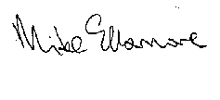

**Mike Ellsmore CPFA**

**Trustee**

**Reserves Policy:**

The Trustees have considered the level of reserves they wish to retain appropriate to the needs of the CIO. This is based on the size of the CIO and level of commitments held currently. The Trustees aim to ensure the CIO will be able to continue to fulfil its objectives even if there is a temporary shortfall of income.

**Risk Review:**

The Trustees conduct periodic reviews of the major risks to which the CIO is exposed and systems and procedures to manage those risks identified are implemented so as to minimise any potential impact on the CIO should any of those risks materialise.

**Plans for the Future:**

The CIO plans to continue its activities in the forthcoming year and beyond subject to satisfactory funding and income levels

**We gratefully acknowledge and thank the support of:**

* Oxleas NHS Foundation Trust
* The London Borough of Bexley
* Hall Place House and Gardens