`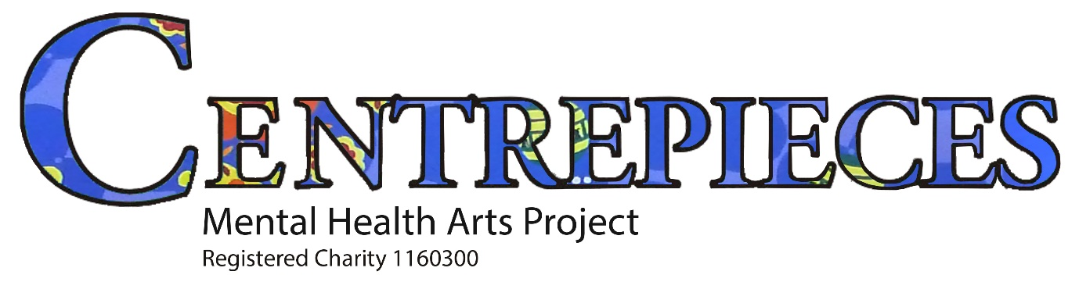

CENTREPIECES ARTISTS UPDATE

JANUARY – FEBRUARY 2020

ART AUCTION 2019
This years Centrepieces Art Auction took place on Friday 29th November at the Pop Up Studios in Bexleyheath. The artwork looked very good in the new space with 180 pieces of artwork up for sale, of which over 70 sold. Total sales amounted to £2.7K raising over £1K for Centrepieces, the rest going to the artists.

LODGE WORKSHOP TIMETABLE (details below timetable)

MONDAY: INDOOR SCULPTURE (Mixed Media) 10:30 – 1:00pm (Lucy Thomas)
ART HEALING (Block 2 Jan- Pop Up Studios) 10:30 – 1:00pm (Peter Kent)
TUESDAY: CREATIVE PORTRAIT TECHNIQUES (Jan) 10:30 – 1:00pm (Christie Cassisa)
ART HEALING ( Block 2 Feb - Lodge) 10:30 – 1:00pm (Peter Kent)
WED: PHOTOGRAPHY 10:00 – 12:00pm (Terry Longley)
THURSDAY: MIXED MEDIA 10:30 – 1:00pm (Lucy Thomas)
FRIDAY: OPEN STUDIO 10:00 – 1:00pm (All artists)
OUTDOOR SCULPTURE 10:30-1:00pm (Christie Cassisa)
SATURDAY: VARIOUS WORKSHOPS (AT THE POP UP) 10:30 – 1:00pm (Various Tutors)

ART WORKSHOPS AT THE LODGE (UNLESS OTHERWISE STATED)
SCULPTURE Lucy continues to run weekly Mixed Media sculptural workshops on Monday mornings, working with various media including clay and papier mache, which cost £3 and do not need to be booked in advance (look out for flyers advertising Lucy’s 2020 programme).
Christie continues to run Friday morning Outdoor Sculpture Sessions covering all aspects of stone and wood carving according to the interest and development needs of individual artists. These are also on a drop in basis costing £3 per session.
CULTURAL SEEDS FUNDED WORKSHOPS (ART HEALING)
ART HEALING: MY JOURNEY Peter Kent is running Block 2 of these sessions at both the Lodge and Pop up Studios. Pop Up on Monday 13th, 20th, 27th Jan and 3rd Feb. Lodge on Tuesday 4th, 11th, 18th and 25th Feb. All sessions 10-1pm. £15 deposit for each block, returnable on completion of the 4 sessions. Participants will be encouraged to explore their own recovery journeys through use of abstract form and colour to create three pieces representing different stages of their journey which will be exhibited in April.
CREATIVE PORTRAIT TECHNIQUES Following on from Merissa’s successful Life Drawing course Christie will be running a 3 week course on learning and practising how to draw and paint a self portrait or someone else, using different media with a photo as reference. Cost £10 (refundable if attending all three as it is a WK funded course). This course is at the Lodge on Tuesdays 14th, 21st and 28th Jan .
PEN AND INK SKETCHING Sue Wieck will be running this course in March on Tuesdays at the Lodge, 2nd/9th and 16th. Bookings to be taken soon, cost £10.
MIXED MEDIA WORKSHOPS Lucy Thomas continues to run these workshops on Thursdays (look out for flyers advertising Lucy’s 2020 programme).
PHOTOGRAPHY GROUP This group meets on Wednesdays between 10 –12pm either at the Pop Up Space Bexleyheath, the Cafeteria at Sainsburys in Crayford, or at the Lodge or Hall Place Visitors Centre, to discuss photography and plan field trips (£1 donation). Contact Terry Longley, Dawn Tomkins, Neil Butler or Alex Spendley if interested, for details of venue.
SATURDAY OPENING AT THE POP UP SPACE
Saturday Opening has now moved for a trial period to the new space in Bexleyheath, with a variety of workshops. Normal opening time is from 10 – 1pm subject to keyholder availability.
See the website www.centrepieces.org for workshop updates or artists@centrepieces.org email group, or telephone the Lodge on 01322 554 589

UPDATE ON THE POP UP STUDIOS IN BEXLEYHEATH
There is a waiting list for the Studio Spaces (20 altogether) with new people joining as others leave, cost £10 per month. The wall space for Themed Exhibitions has been used for several exhibitions since the summer, most recently the Art Auction. Other new Themed Exhibitions are being planned for 2020, including Featured Artists and ‘People in Bloom’. There is a rotating display of artwork featuring Studio Artists on the rear wall and in the shop window, which has recently held ‘Remembrance Day’ and ‘Winter Wonderland’ displays. Artwork has been selling well and the space has been a great stimulus for this, and for attracting interest from the public and new artists and volunteers.
BEXLEYHEATH RAILWAY STATION It has been agreed that the waiting room can be used for Centrepieces art exhibitions on a rotating basis. Mark Harrison exhibited there initially and now Christie Cassisa. Contact Centrepieces if interested as the work needs to be of a particular size and depth in order to fit into their standard poster type locked frames. We are also looking for a volunteer to support these rotating exhibitions.
CREEK CREATIVE STUDIOS IN FAVERSHAM Christie Cassisa held our most recent exhibition in this lovely café art gallery from 14th – 27th October. Let us know if you would like to be considered for a future solo exhibition either at this venue or elsewhere.
LIBRARY EXHIBITIONS Erith and Sidcup Libraries are both being booked soon for 2020.
SLADE GREEN COMMUNITY CENTRE We continue to rotate artists work being shown here, and our first project took place with C/P artists drawing Life Model local War Veteran Alexander Borrie, which was highly successful.
MERCHANDISE The new Centrepieces T shirts with a colourful design by Kim Campbell are now selling from the Lodge at £10 each, available in L, XL , XXL, and a few larger sizes as well. These are primarily for workshop tutors and public events, but are also generally available on sale to Centrepieces artists and the public. Karen has designed a Calendar for 2020, available to order. Centrepieces Trustee Britta Von Zweigbergk’s second new book, ‘Centrepieces, A Story of Mental Health and Art in Bexley’ with input from many people involved in Centrepieces over the years has been for 2nd reprint and is on sale at the Lodge at £14.99, available to Centrepieces artists and volunteers at the reduced rate of £12.99. Britta has also just finished another book, an anthology of Poems by Bexley Hospital patients including some Centrepieces artists, which will soon be published under Centrepieces Press.
FUNDRAISING
A consultation with local groups including Centrepieces is now starting following the recent successful £1M bid to the Arts Council ‘Creative People and Places’ scheme. This has involved the Erith Exchange, Peabody Trust, Beaux Arts and several other organisations for a project entitled ‘Made in the Estuary’. Centrepieces Trustees Guy Tarrant, Rosie Eaglen and Fiona Millar are on the Creative Board and will be monitoring progress.
MORE HALL PLACE INSTALLATIONS We have now received some ideas for outline proposals of further artwork in the Gardens at Hall Place, for which Centrepieces will be seeking funding. The ‘TWELVE’ as the last series was called, has been scaled down to ‘SIX’. Please make contact asap if you have any further suggestions/ feel able to take on/ help with any of these projects.
DISCOUNT CARDS AT HOBBYCRAFT Centrepieces Trustee Guy Tarrant has negotiated a 10% discount for Centrepieces artists at the Crayford branch of Hobbycraft. The cards are being produced and will soon be available from the Lodge. The Hall Place Visitors Café have also agreed to give discount on production of these cards.
BEXLEY GRAMMAR SCHOOL Karen and Peter visited and spoke to students at this school, following an invite to Centrepieces for the second year running to be the nominated charity by two of the year 8 classes, in a competition which last year raised £1K for C/P as the eventual winners.
VISIT TO CROSSNESS OLD SEWAGE WORKS C/P Trustee Rosie Eaglen is organising a visit for Centrepieces artists, after their new director expressed interest in offering casting workshops and possibly siting some C/P public art in their grounds.

