Come And Have Some Fun at the Centrepieces
CARNIVAL WORKSHOPS
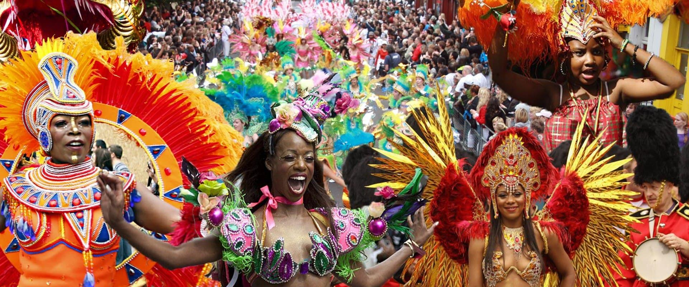

Merissa and Stella will be leading four workshops.
Two at The Lodge on Tuesday 17th & 24th August 2 – 4pm
Two at Erith Exchange on Saturday 14th & 21st August 12 – 3pm*
*One-hour slots

You will be taught how to make Carnival costume headdresses and arm bands etc and learn about the history of carnival.
And if you are interested come along and help at the Centrepieces Stall at the:
ERITH MADE FESTIVAL BANK HOLIDAY MONDAY 30TH AUGUST
at Pier Road Erith
Workshop Venues:
The Lodge
Hall Place, Bourne Rd,
Dartford, DA5 1PQ

The Exchange
The Old Library, Walnut tree Rd
Erith, DA8 1RS

Please book in advance due to limited space
You can book places at both venues via the Centrepieces workshop booking system: suet998@gmail.com or call Geoff on 01322 554589

