

**The Stables Gallery**



***Fri 22nd March -***

***Tue 23rd April***

***2024***

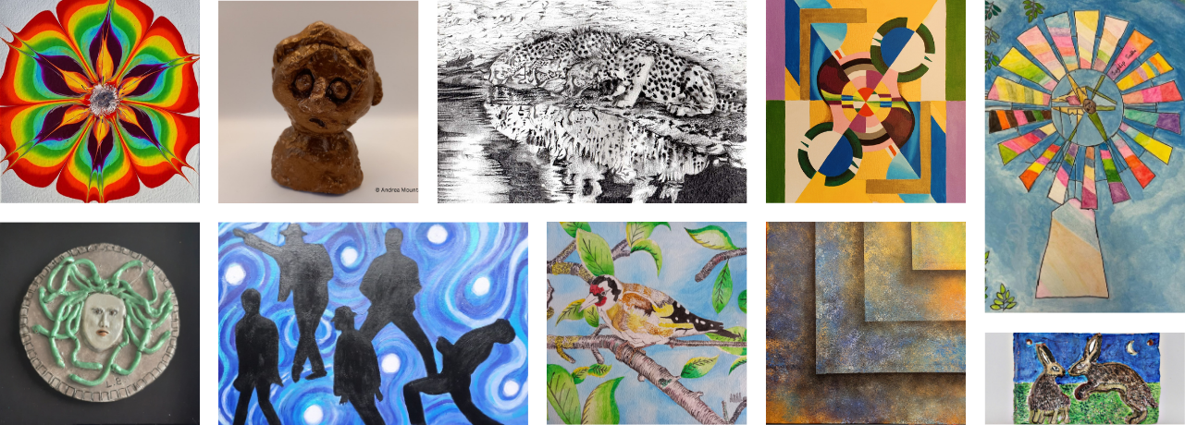

**s**

**This Centrepieces Exhibition incorporates the Mental Health Awareness Week 2024 theme of ‘The Benefits of Movement to Mental Health’**

**Mental Health and Movement**

*For further information contact: Geoff Norris or Karen Larkin*

*at The Lodge, Hall Place, Bourne Road, Bexley, DA5 1PG*

*info@centrepieces.org 01322 554589 www.centrepieces.org*

**Visitor Centre**

**Stables Gallery**

**Hall Place & Gardens**

**Bourne Road**

**Bexley DA5 1PQ**

**Information line: 01322 526574**

**www.hallplace.org.uk**

**www.hallplace.org.uk**

**Free Parking and Entry**

Official opening Sat 23rd March 11am

with the Mayor of Bexley. All welcome.