

ANNUAL REPORT & ACCOUNTS
AT 31 MARCH 2020
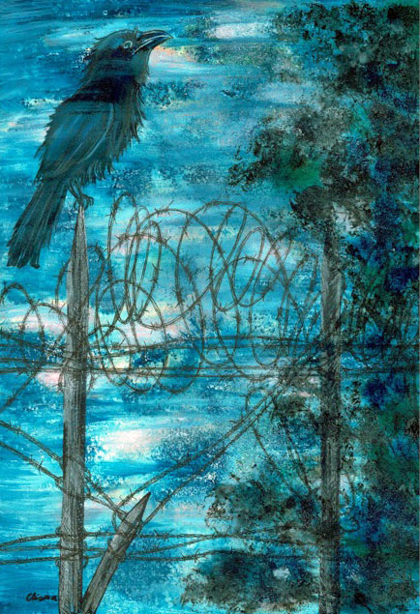

‘Lockdown’ by Centrepieces Artist Dorota Chioma

CENTREPIECES ANNUAL REPORT & ACCOUNTS

1st April 2019 to 31st March 2020

Chairman’s Report:
Well where do I start this report! The world is a very different place from where it was a year ago. Covid 19 hit us at the very end of our financial year and the impacts were not really seen in this period. The year was one of great achievement for us with the Pop-Up Studios in the former Argos Store at Bexleyheath proving a great success. It gives us a real public face and I am personally grateful to all the volunteers who helped get the facility up and running. We continue to be active in promoting our own exhibitions and developing our programme of workshops and events.
The months since our year end have been challenging for everyone but trustees and volunteers continue to be positive in meeting the challenges imposed by Covid 19. I am amazed at how innovative we have been in running online sessions for our members and maintaining much needed lines of communication.
One of the people whose life inspired me over the years is Ernest Shackleton (1874-1922), who got all his men back safely after being stranded on ice flows in the Antarctic for 18 months back in the days when rescues were not an option.
‘Difficulties are just things to overcome’

Mike Ellsmore
Chair of Trustees

Coordinator’s Report:

Last year started off as once again a time of fantastic positive transformation for Centrepieces. A significant event was the acquisition of the old Argos shop space in Bexleyheath in July 2019, which although on a temporary lease has enabled us to create studio spaces for about 20 Centrepieces artists and scope for more, with large areas for artists to exhibit and sell their artwork and for themed exhibitions to take place such as World Mental Health Day ‘Suicide Prevention’, ‘Amnesty Day’ and the Centrepieces Annual Art Auction last December.
The presence of the Pop Up Studios in Bexleyheath Broadway has helped enable better access by the general public to see what Centrepieces does, purchase artwork and other items produced, and for us to generally improve public awareness of mental health issues. There have been several collaborations with schools and young people including the ‘Young Minds’ group involving series of art workshops in the Studios.
Up until Lockdown most of Centrepieces’ busy programme of art workshops had been taking place in our permanent premises at The Lodge in the grounds of Hall Place and Gardens, with the work of the project expanding very smoothly and quickly to make the most of the potential of the two premises.
With the onset of the Covid19 pandemic lockdown in March we had to think on our feet, which very quickly led to the development of an alternative online arts programme which we have called ‘Operation Art Lockdown’. This was a massive piece of work, undertaken by Karen Larkin, Centrepieces Assistant Coordinator and other Centrepieces volunteers and tutors Peter Kent, Lucy Thomas and many others, with good back up from the arts admin, finance team and others, either working from home or at The Lodge whenever possible.
Throughout this programme we have been able to offer an extensive series of live daily Zoom workshops with an active social media presence on Facebook and Instagram, Whatsapp support groups and so on. We have created and maintained an active support network for all artists through email and telephone calls where needed, recognising that not everyone has been able to take part in the online art activities, so we have been posting newsletters and other information to these people to ensure that everyone has been able to get mental health support through art as required. There is no doubt that the pandemic has had a significant effect on people’s mental health in general, and potentially even more so for Centrepieces artists. We have already received positive feedback from some on how the programme has helped them through recent difficult times.
The pandemic also led to us increasing Centrepieces’ fundraising activities, making a number of applications of which all the major ones have been a success; Winners Chapel in Dartford, the Baring Foundation, National Lottery Covid19 emergency fund and the Bexley Council Business Discretionary Grant. We are also grateful to have been inundated with donations from other organisations and individuals that have helped secure our survival; Bellway Properties, Sidcup Rotary Club and the Jamie Shand Trust, to name but a few.
We are, at the time of writing this report, in the second wave of Lockdown and have been utilizing the funds raised to buy equipment to ensure the safe reopening of both our premises whenever this becomes possible, and the Centrepieces team of volunteers has continued to work tirelessly to prepare for this. In the meantime ‘Operation Art Lockdown’ goes from strength to strength, so it is expected that when the Lodge and Pop Up Studios eventually reopen to artists that it will continue in some form as a regular ongoing part of what Centrepieces offers.

We have managed to get one major ‘real gallery space’ exhibition in place, our annual Open Exhibition in the Stables Gallery at Hall Place, this year called ‘Lockdown Art’, which is showing artwork produced by Centrepieces artists during Lockdown, some of which came from the Operation Art Lockdown live Zoom workshops and includes statements by artists about their Lockdown experiences. This exhibition opened in September 2020 but has now been extended until just before Christmas subject to the reopening of the Stables Gallery.
We have also supported Centrepieces artist Dorota Chioma to hold a successful solo exhibition entitled ‘Mental Health in Pictures’ at the Creek Creative Gallery in Faversham in between the recent periods of full Lockdown.
I’d like to finish by saying a big thanks to the whole team of volunteers, Trustees and artists who have helped Centrepieces survive and even flourish over the last year, and to echo what Mike our Chairman wrote earlier, about how getting through recent times of adversity has only helped us to grow stronger.

Geoff Norris

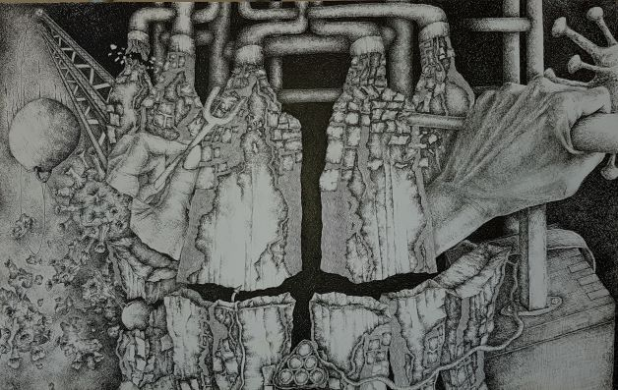
‘Dis-Ease’ by Centrepieces artist Cheryl Loom

Legal and Administrative Information:

Registered Office Address:
The Lodge
Hall Place
Bourne Road
Bexley
Kent
DA5 1PQ

CIO Number: 1160300

Trustees of Centrepieces:

Andrew Grieve
Mike Ellsmore
Guy Tarrant
Britta Von Zweigbergk
Jenny Watson
Olwyn Sinclair
Rosie Eaglen
Fiona Miller Appointed 21st August 2019

The Trustees named have served during the period of the accounts. Appointment of Trustees is governed by the CIO Memorandum and Articles of Association and the Trustee Board is authorised to appoint new trustees to fill vacancies arising through resignation, or the death of an existing trustee.

Structure, Governance and Management:

Centrepieces is a Charitable Incorporated Organisation (CIO) registered with the Charities Commission on the 3rd February 2015. The CIO has a volunteer Coordinator and a number of members who take on allocated voluntary responsibilities on a day to day basis. A Board of Trustees is responsible for the strategic direction and funding of the organisation, recruitment of new trustees as and when necessary, activities which are supported by 3 committees who meet periodically to discuss their specialist areas including Arts, Finance and Funding of the CIO, and then report to the full Board of Centrepieces.

Objectives of organisation:

To promote the recovery of adults in the London Borough of Bexley and surrounding areas who experience or have experienced, mental health problems by providing resources and support to enable them to participate in arts and related mental health enhancing activities, and to develop artistically and to achieve better social inclusion through art related activities.

- To promote mental health recovery through art
- To provide an outlet for artists with mental health issues to exhibit and sell their artwork
- To achieve long term financial sustainability
- To achieve long term security of tenure with regard to our premises
- To provide a safe and stimulating environment for our members
- To apply for available and appropriate funding
- To achieve a funding and income level allowing for the employment of paid staff

Centrepieces CIO – Financial Report

It gives us pleasure to present our fifth financial report, covering the year to 31st March 2020

This year has seen our cash reserves reduce from £25,869 to £20,321, largely as a result of a reduction in our unrestricted funds which reduced from £20,761 to £14,469. The year was a year of investment; we took the opportunity to upgrade our IT infrastructure and invested in setting up the Pop Up Studios. The accounts presented are divided into unrestricted and restricted funds. Unrestricted funds can be used entirely at the trustees’ discretion. Restricted funds must be used for a specific purpose as prescribed by the donor. During this reporting period, Centrepieces received donations on a restricted basis of £7,603. Main items were £4,063 for the Art Healing Project - a visual arts project focused on using abstract art to express the individual’s journey through mental health - funded by Cultural Seeds, and from private donations: £1250 for the Mental Health Awareness Project and Artist Support, and £1,875 for future exhibitions.

The balance on the restricted funds at the year end was £5,852.

Turning to our unrestricted funds, gross receipts totalled £25,703 whilst payments totalled £31,995. This resulted in a deficit for the year of (£6,292)

As noted earlier, at the end of the reporting period our unrestricted reserves totalled £14,469 down from £20,761 the previous year and are at an adequate level to ensure the continued operation of the organisation. Although outside the reporting period, recent successful funding applications have placed Centrepieces in a robust position financially, well placed to meet the challenges ahead.
I continue to be grateful to Jean Lyons and Annie Greywoode for their hard work and commitment in keeping Centrepieces’ finances in a well ordered and controlled state.

Michael Ellsmore, CPFA
Trustee

Financial statements report and review:

- In my opinion the accounts above give a true and fair view of the CIO affairs at the end of this financial year.

- Have been prepared in accordance with the requirements of the Charities Commission for Charitable incorporated Organisations (CIO).

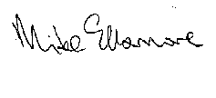
Mike Ellsmore CPFA
Trustee

Reserves Policy:

The Trustees have considered the level of reserves they wish to retain appropriate to the needs of the CIO. This is based on the size of the CIO and level of commitments held currently. The Trustees aim to ensure the CIO will be able to continue to fulfil its objectives even if there is a temporary shortfall of income.

Risk Review:

The Trustees conduct periodic reviews of the major risks to which the CIO is exposed and systems and procedures to manage those risks identified are implemented so as to minimise any potential impact on the CIO should any of those risks materialise.

Plans for the Future:

The CIO plans to continue its activities in the forthcoming year and beyond subject to satisfactory funding and income levels

We gratefully acknowledge and thank the support of:

- Oxleas NHS Foundation Trust

- The London Borough of Bexley

- Hall Place House and Gardens

